# Team 24 – Sprint 1 Testing Document

Sakshi Choudhary, Giorgi Khmaladze, Nick Litman, Mihir Somani, Conley Utz

User Story #7

**Test 1:** **Given that the user has filled all required fields of a listing, if the user selects “1” as the quality, then the database should accurately represent this value**

Purpose: To meet acceptance criteria that every quality ranking is functional

Step:

1. User properly inputs data in all required fields and selects “1” for the “Quality” field

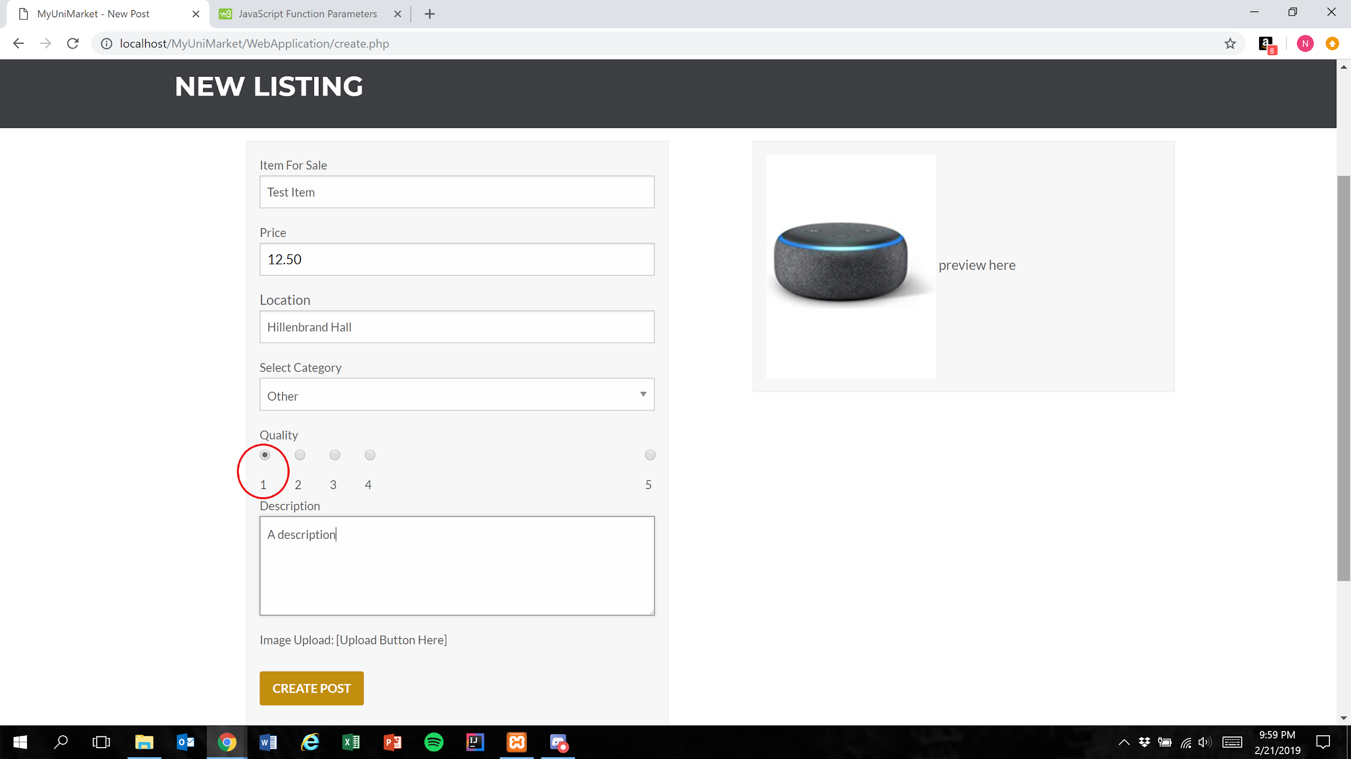

1. User presses the create post button

Figure 1

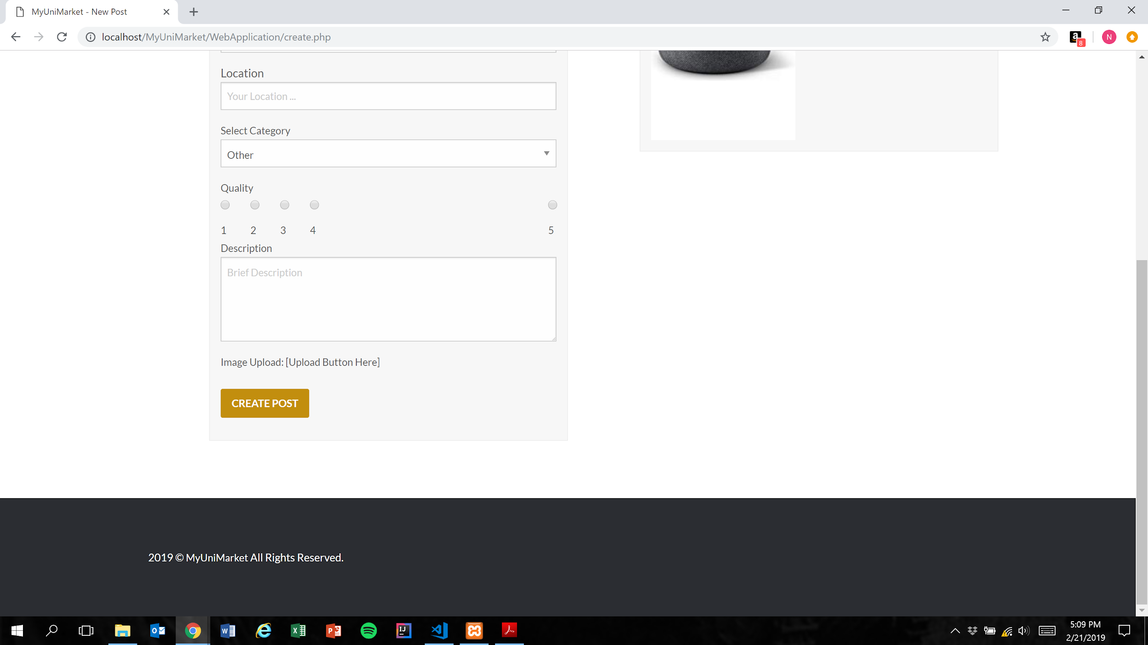

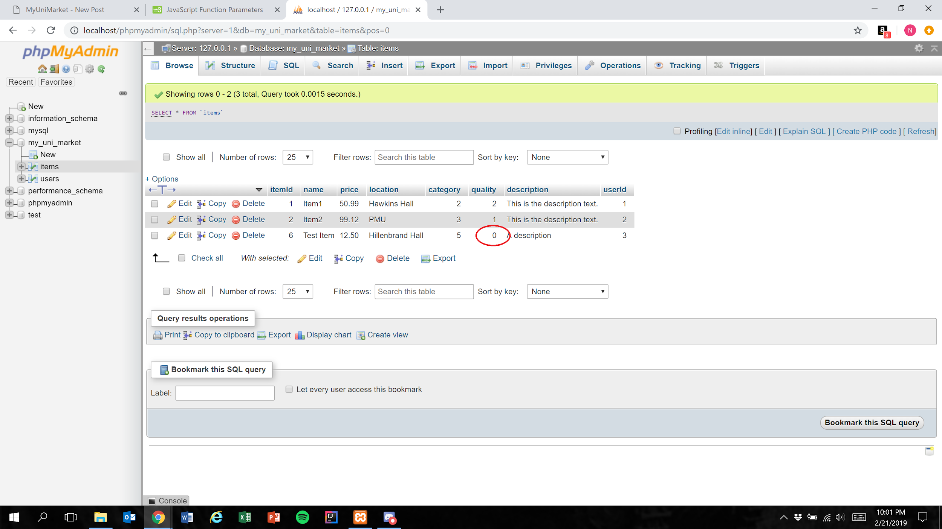

Expected Result: Quality field is represented in the database as 1 less than the user’s selection

Test Result: **PASSED**

**Test 2:** **Given that the user has correctly has filled all required fields of a listing, if the user selects “2” as the quality, then the database should accurately represent this value**

Purpose: To meet acceptance criteria that every quality ranking is functional

Step:

1. User properly inputs data in all required fields and selects “2” for the “Quality” field

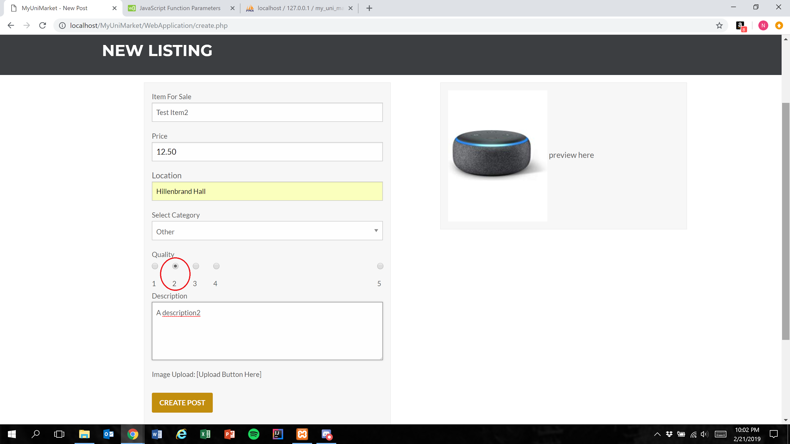

1. User presses the create post button (Figure 1)

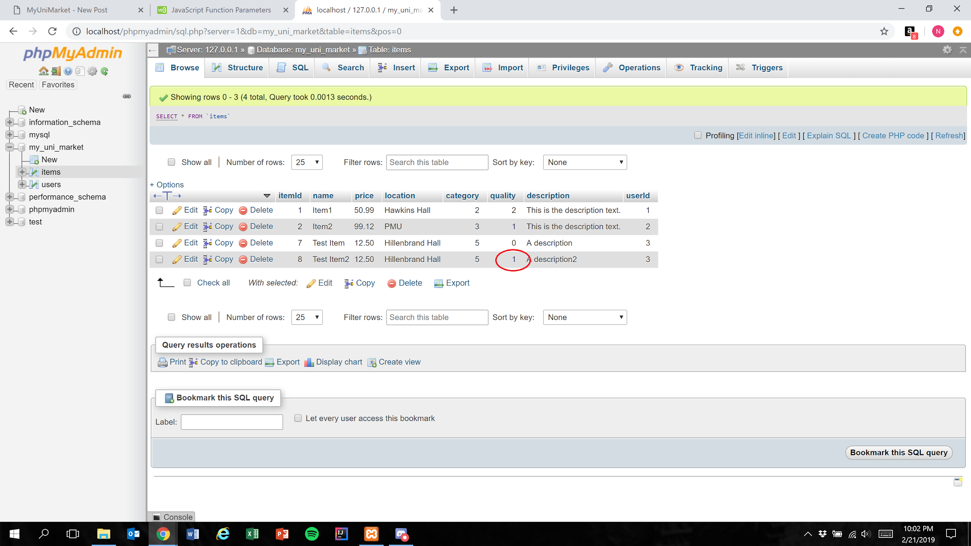

Expected Result: Quality field is represented in the database as 1 less than the user’s selection

Test Result: **PASSED**

**Test 3:** **Given that the user has correctly has filled all required fields of a listing, if the user selects “3” as the quality, then the database should accurately represent this value**

Purpose: To meet acceptance criteria that every quality ranking is functional

Step:

1. User properly inputs data in all required fields and selects “3” for the “Quality” field

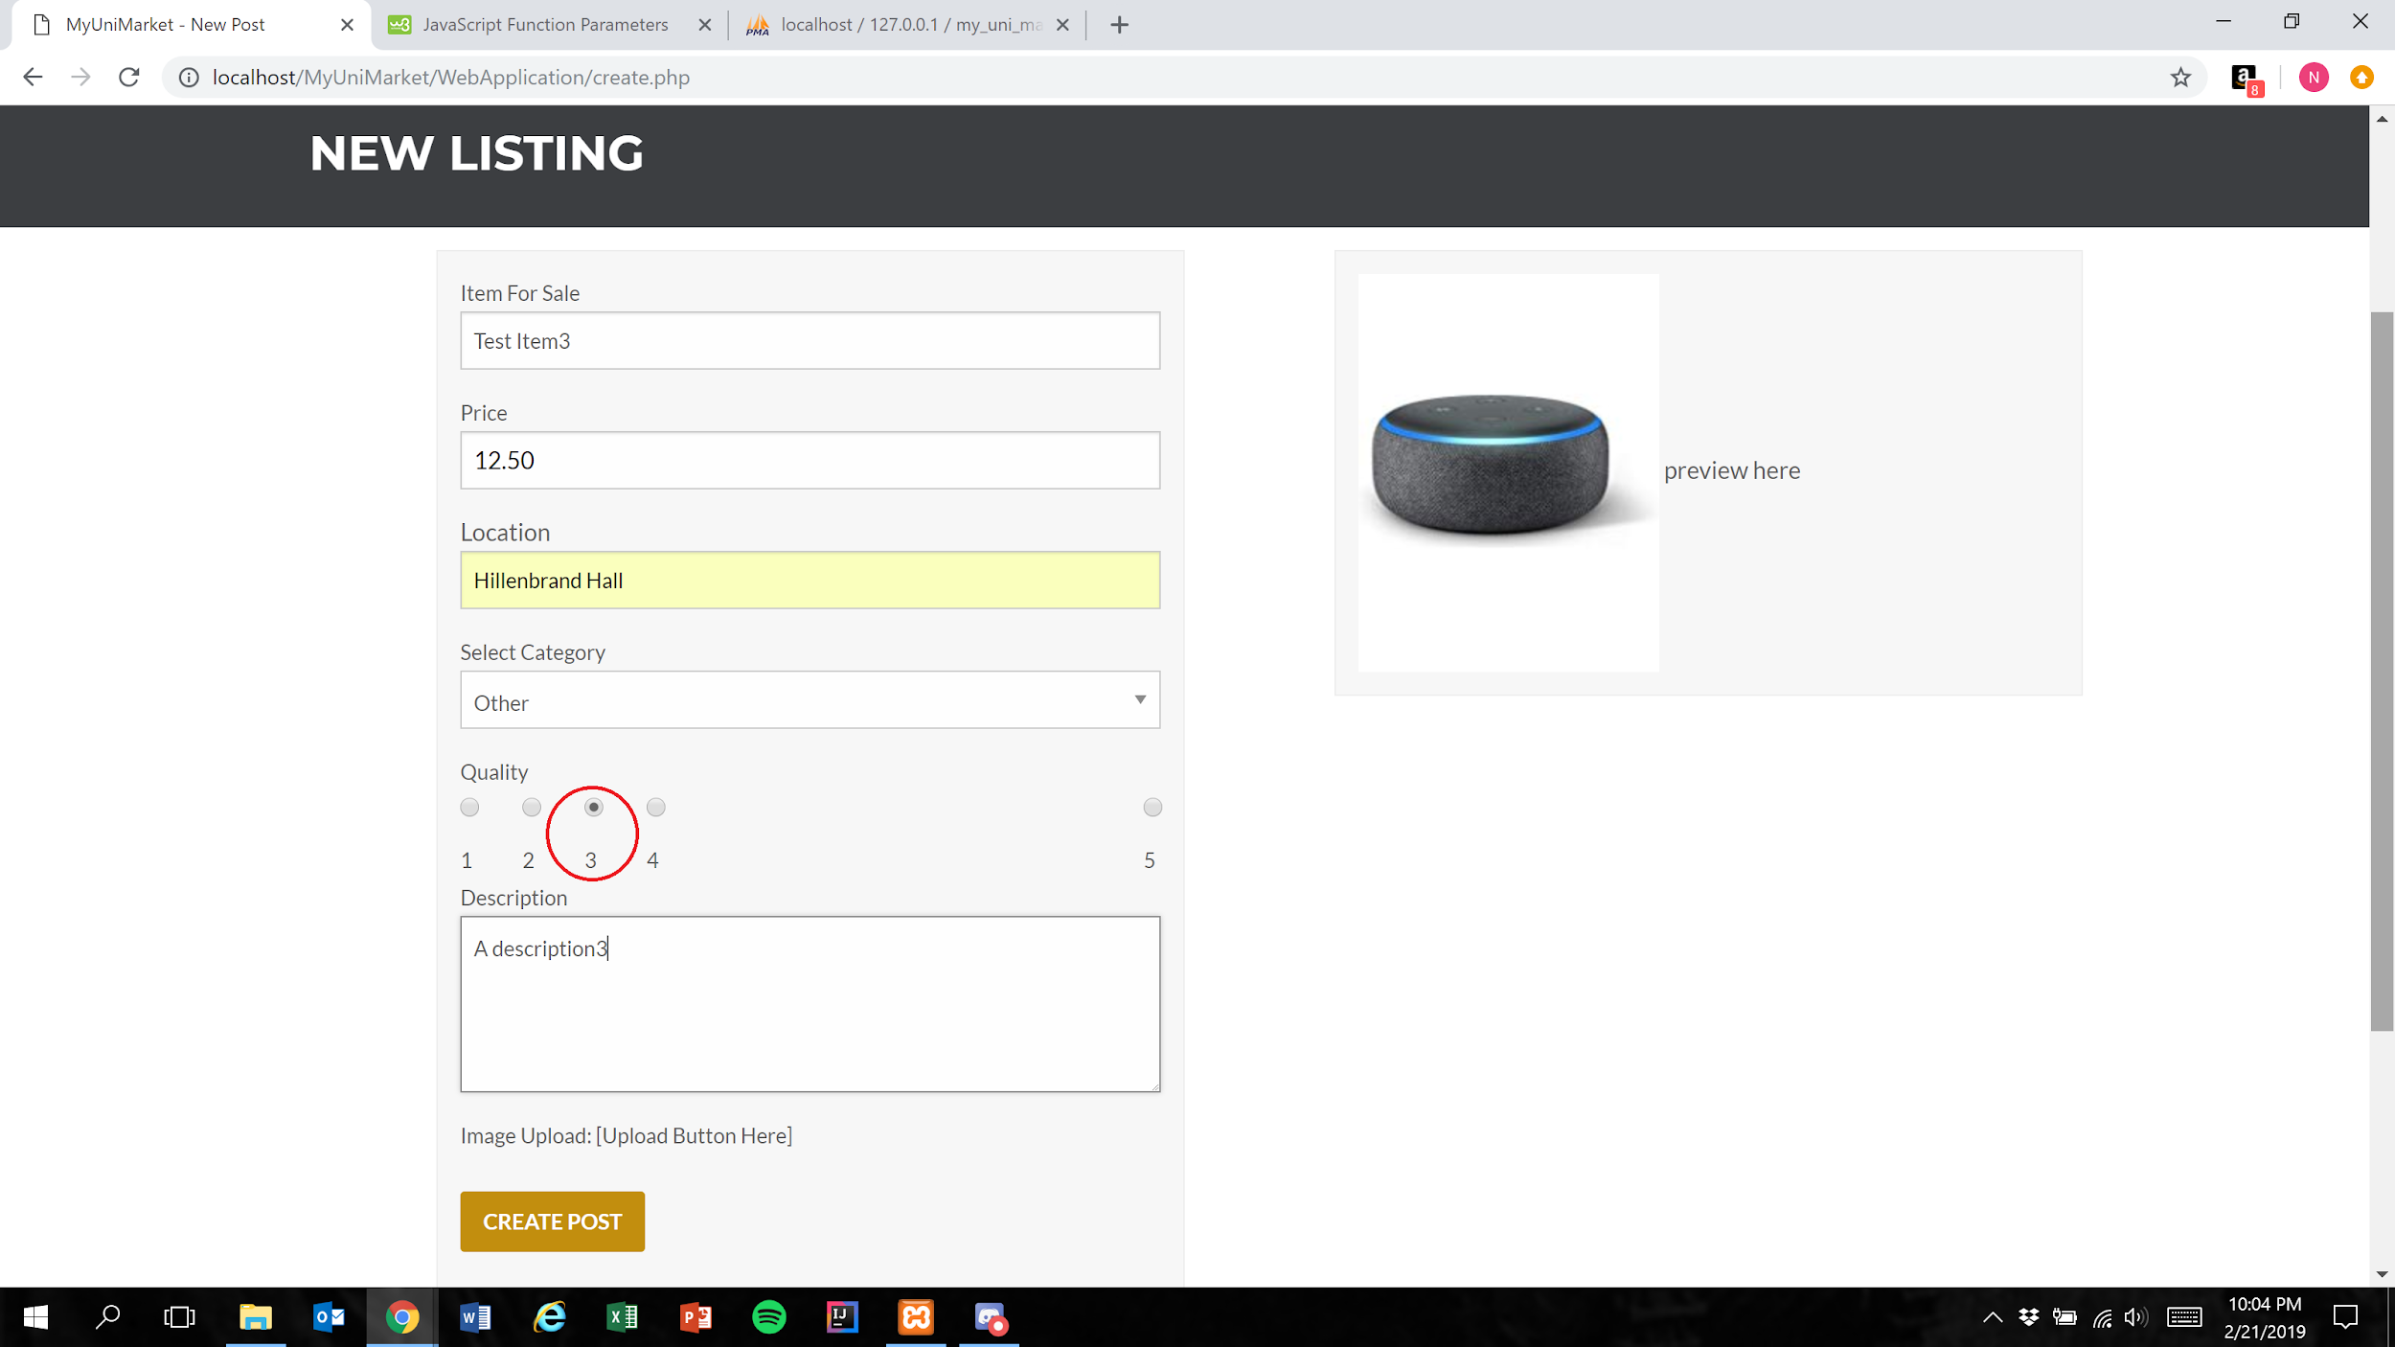

1. User presses the create post button (Figure 1)

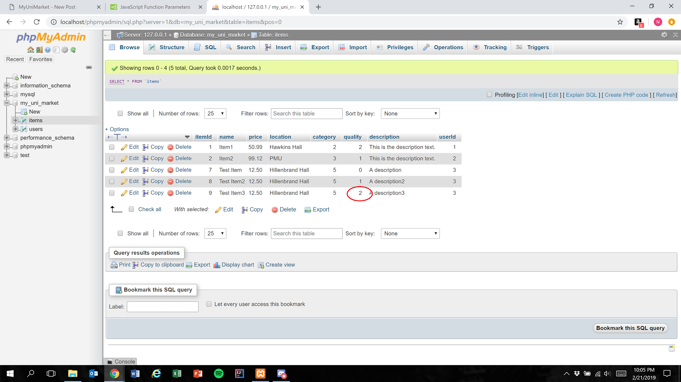

Expected Result: Quality field is represented in the database as 1 less than the user’s selection

Test Result: **PASSED**

**Test 4:** **Given that the user has correctly has filled all required fields of a listing, if the user selects “4” as the quality, then the database should accurately represent this value**

Purpose: To meet acceptance criteria that every quality ranking is functional

Step:

1. User properly inputs data in all required fields and selects “4” for the “Quality” field

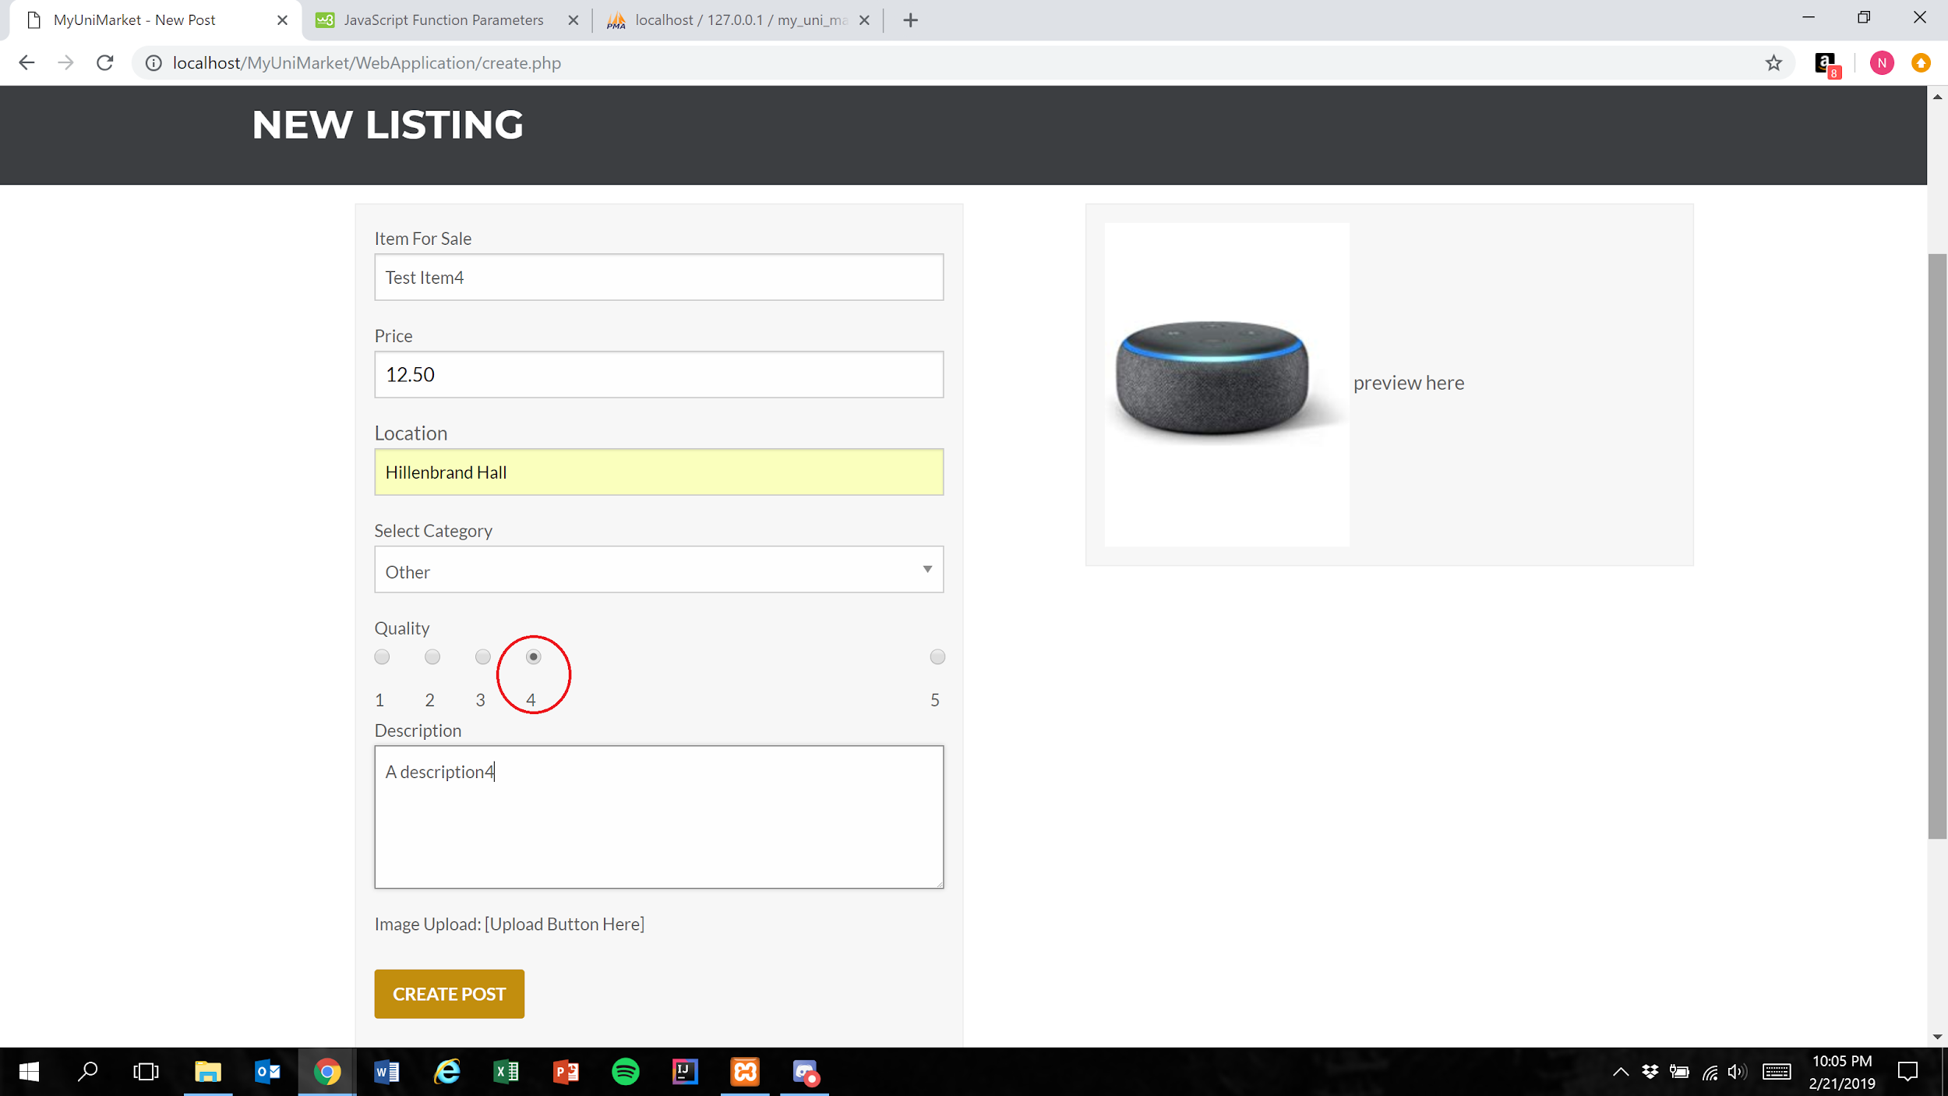

1. User presses the create post button (Figure 1)

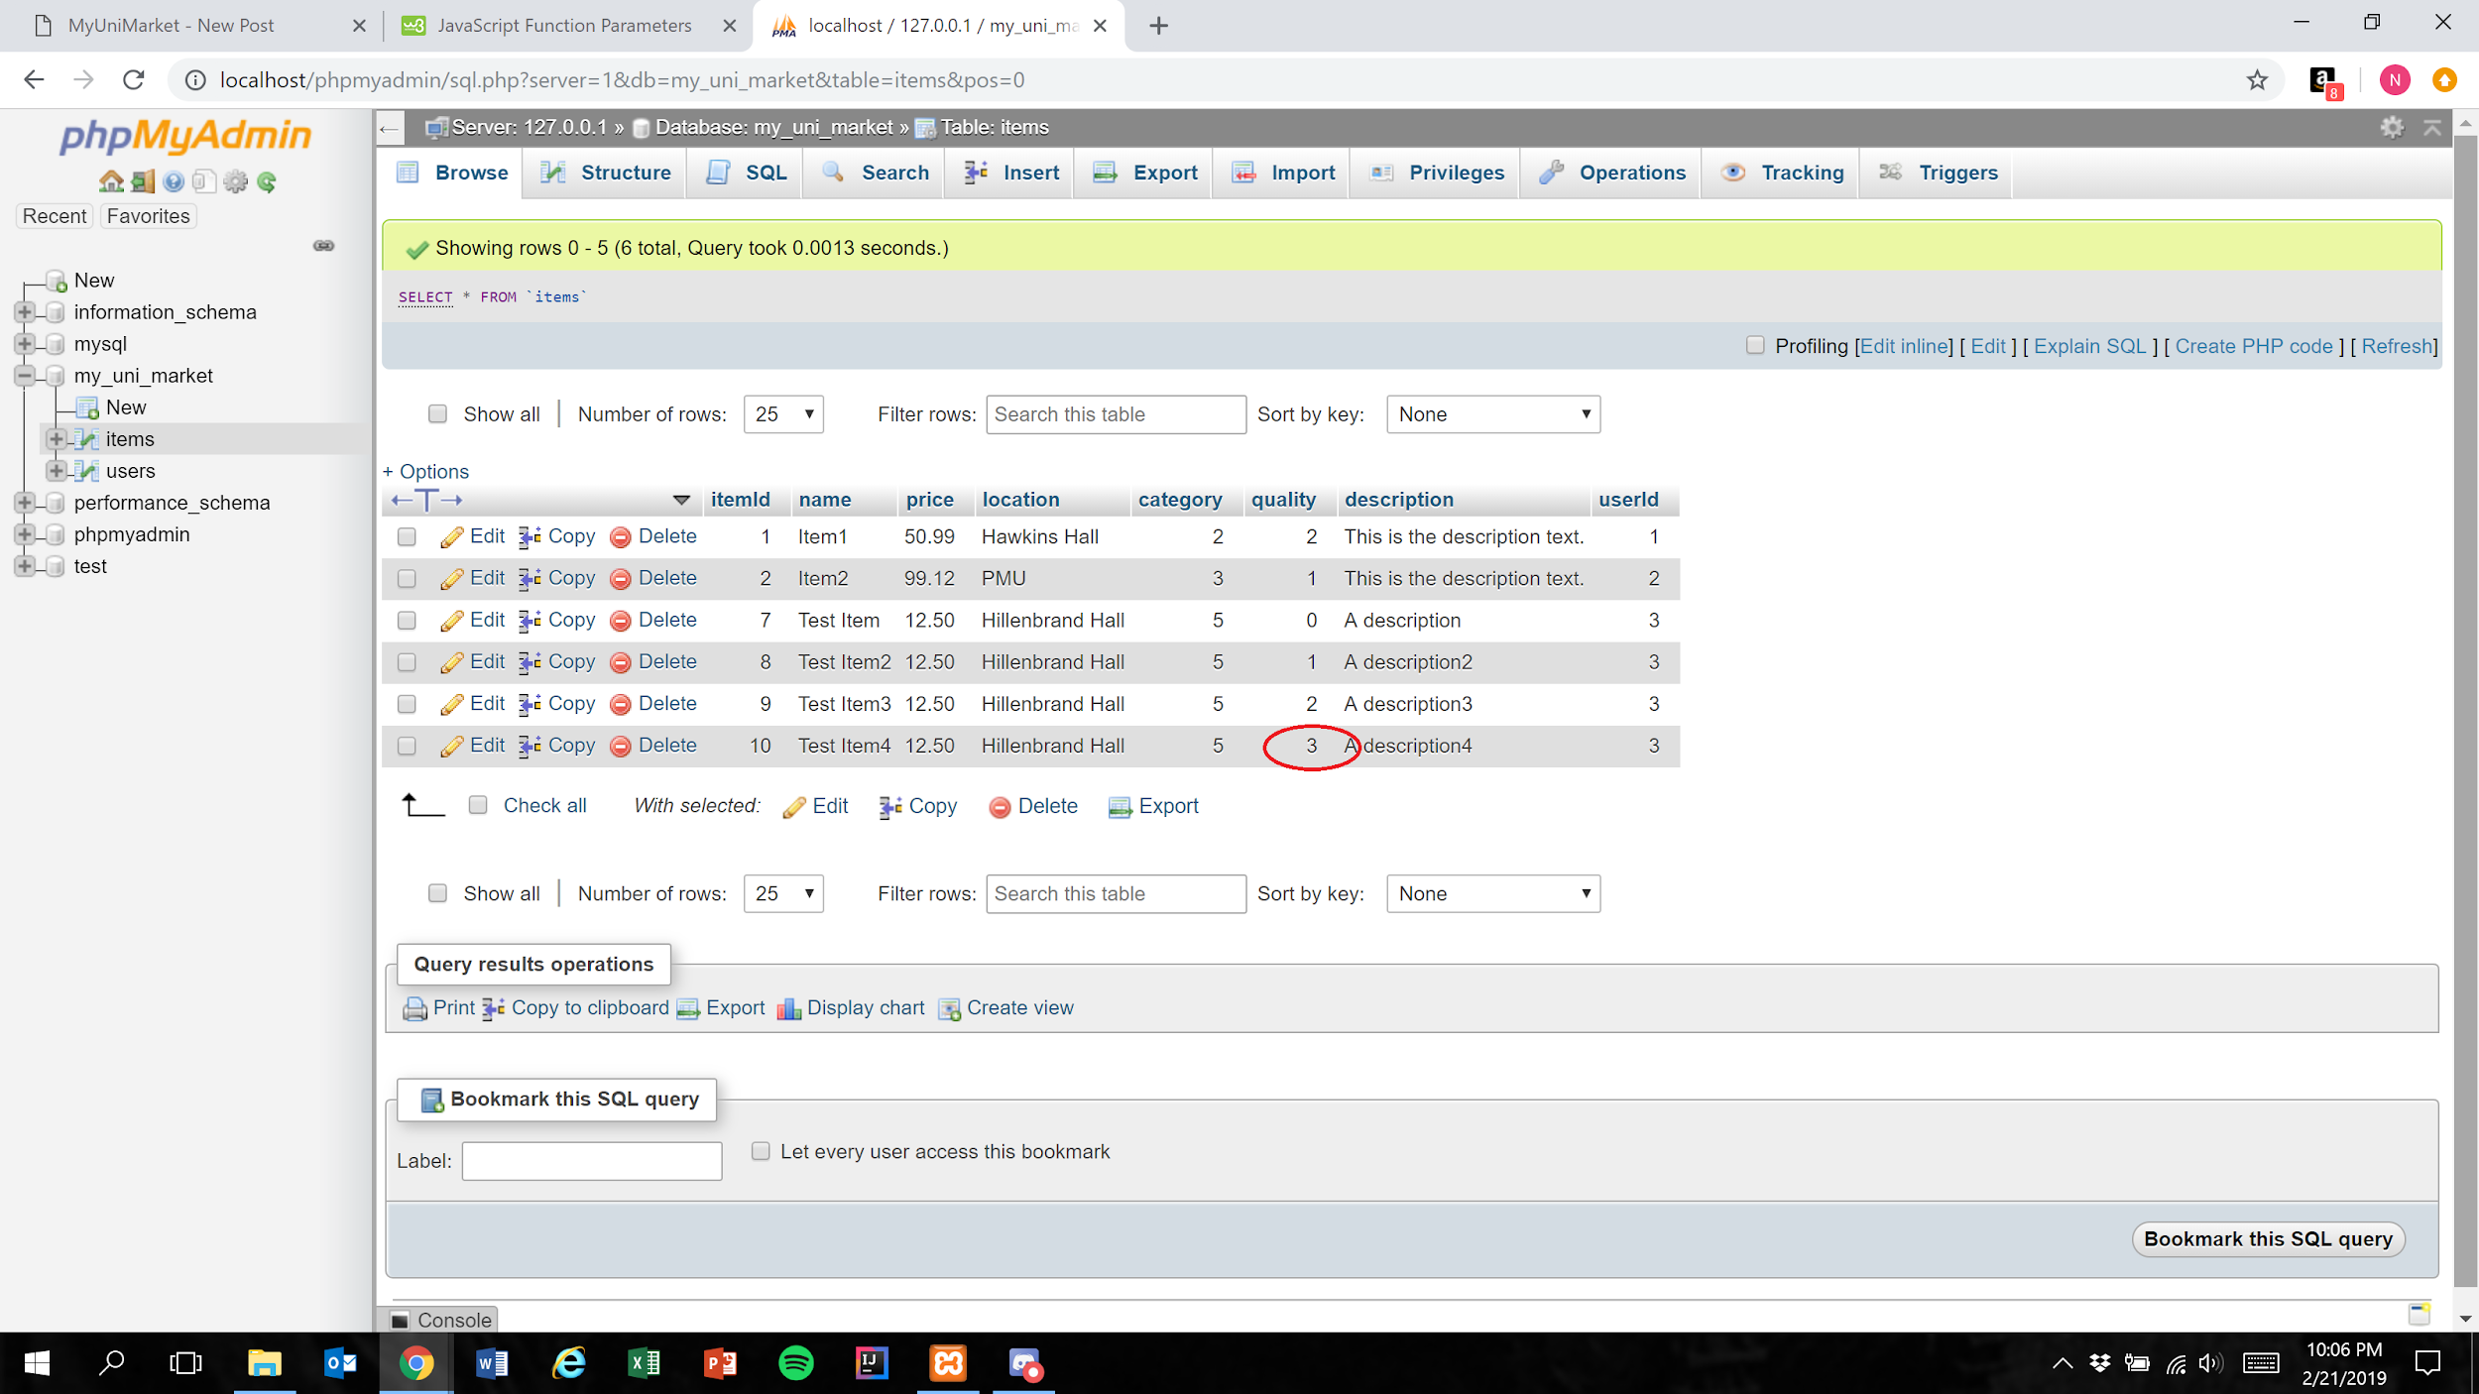

Expected Result: Quality field is represented in the database as 1 less than the user’s selection

Test Result: **PASSED**

**Test 5:** **Given that the user has correctly has filled all required fields of a listing, if the user selects “5” as the quality, then the database should accurately represent this value**

Purpose: To meet acceptance criteria that every quality ranking is functional

Step:

1. User properly inputs data in all required fields and selects “5” for the “Quality” field

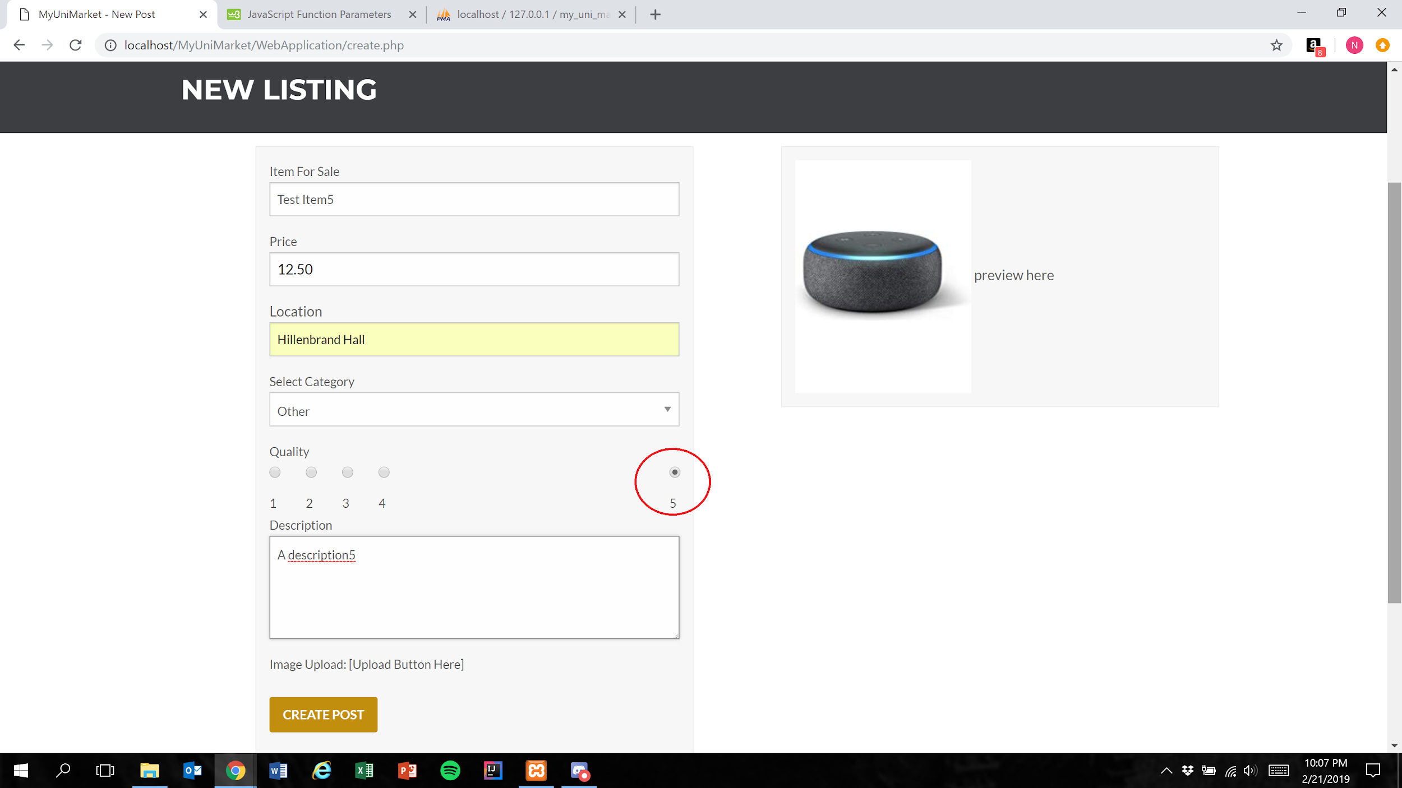

1. User presses the create post button (Figure 1)

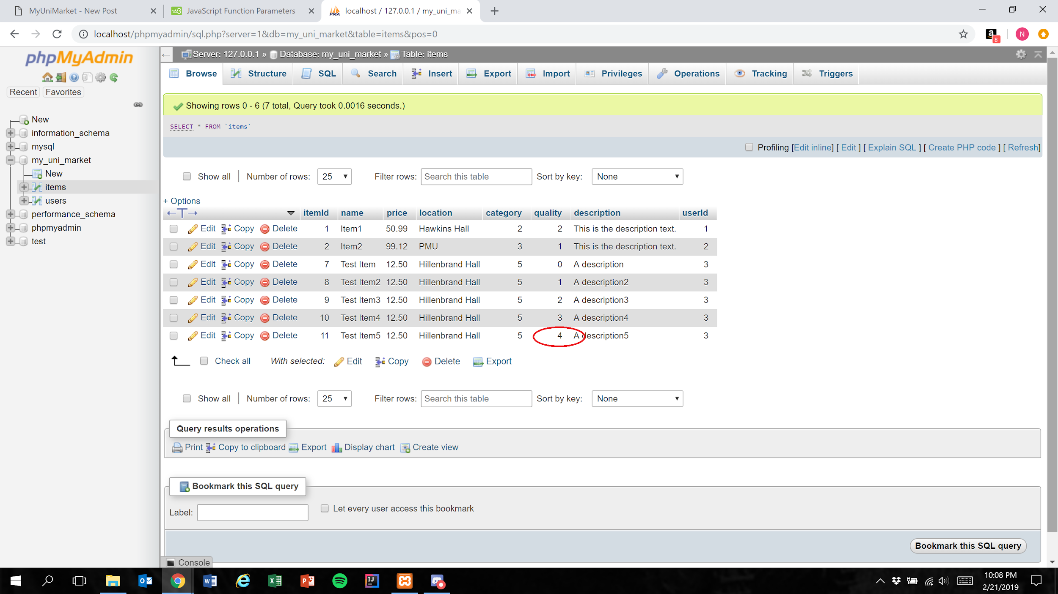

Expected Result: Quality field is represented in the database as 1 less than the user’s selection

Test Result: **PASSED**